2025 Saturday Education Events Registration
____ October 11 Springfield
LRS
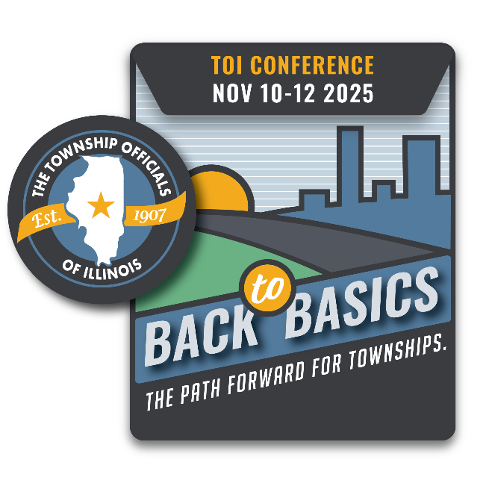
____ October 25 St. Charles
Clark Mosquito Abatement

County Township
Address
City State Zip
Contact person name, email, and phone number:

Names & Email of those who will attend (please print clearly):
Supervisor: Township Clerk: Highway Comm.: Assessor: Trustee: Trustee: Trustee: Trustee: Collector: Other/title:
Registration is $50 per location, per person or $400/township for up to nine attendees. On-site registration is $75 per person. No refunds will be given once TOI has confirmed attendance with venue.

*Please make checks payable to the Township Officials of Illinois; mail to 3217 Northfield Drive., Springfield, IL 62702. Forms may also be emailed to teresa@toi.org. If you are paying by credit card, only Visa and MasterCard are accepted:

Name, as it appears on card: Credit Card Number Exp.:

